# Exercise: Bugs and Bug Tracking

This document defines the exercises and homework assignments for the [**"QA Basics" Course @SoftUni**](https://softuni.bg/trainings/4064/qa-basics-march-2023).

Fill the provided **MS Word document template**. Put the **solution** for each exercise in the document. Name your document Bug-Tracking-Homework-FirstName-LastName.docx. Submit this document as your homework.

## Bug Hunting: Google Home Page

You are given a picture of the **homepage of Google**, opened with a Google Chrome browser. Examine the picture and **list the errors you can detect at first glance**. Then, you can open <https://google.com> for comparison and list the rest of the errors you have found after seeing it.

|  |  |
| --- | --- |
| Bugs: |  |

Look at the legend to judge your results:

|  |  |
| --- | --- |
| Bugs Found |  |
| 0 – 2 | **Poor** |
| 2 – 4 | **Average** |
| 5 – 7 | **Good** |
| 8 – 10 | **Excellent** |
| 11 – 13 | **Exceeds Expectations 😉** |

## Bug Hunting: Notepad Application

One of the trainee developers has developed a **text pad** kind of application. Below is one of the screenshots of the application. Can you list out bugs/issues, which the trainee developer should take care of?

**Hint 1:** There are 10 bugs/issues.

**Hint 2:** You can open Microsoft’s Notepad application for reference.

## Bug Reporting: Gmail

As a tester, the best part of the job is to report defects. We would like to know how you would report the following defect (you can decide upon the fields you want to include, while reporting the defect in the best way).

**Write a detailed defect report for this sample defect**:

"After logging into Gmail, it navigates to Google.com"

**Hint:** Follow the bug reporting example from slide 9 of the Bugs-and-Bugs-Tracking presentation.

## Bug Reporting: Reset Password

**Defect reporting** for the following issue:

* **Requirement**: After registering to the site – samplepage.com, a new user receives an e-mail, which contains a link to reset the initial (default) password.
* **Issue**: When the user registers via mobile, he receives the e-mail two times.
* **Log a defect report** for this issue with all required defect report fields.

## Register in Atlassian Jira Cloud

Create your own **Jira bug tracker online**: [https://www.atlassian.com/software/jira/free](https://www.atlassian.com/try/cloud/signup?bundle=jira-software&edition=free).

* Graphical user interface, text, application

  Description automatically generated Graphical user interface, text, application

  Description automatically generated

1. Create a new **project** in your Atlassian account. Choose “Bug Tracking” from “Software development” Project templates

1. **Name** your project.

1. **Skip** selecting additional tools and hit **Done.** Wait for your project to be created.
2. Your project is now ready.
3. Go ahead and create a **test issue** in your new Jira project.

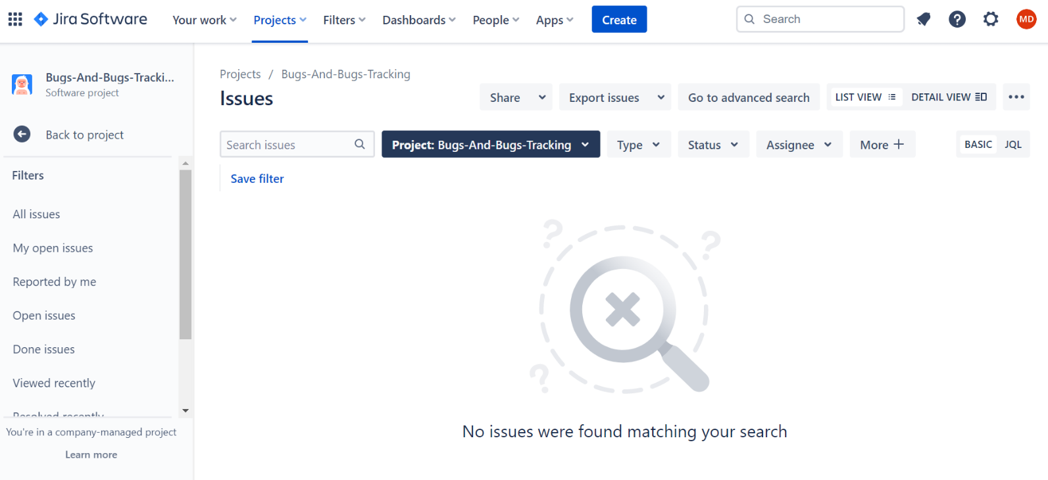

## Bug Reporting: Registration Form

As a software tester, what do you do? Of course, testing the software, you would say……… Okay, can you find out the defects on the provided registration form?

* <http://softuni-qa-loadbalancer-2137572849.eu-north-1.elb.amazonaws.com/registration-form-bugs/>

Keep in mind the following **field requirements**:

* **Username** consists of **no less than 6** **alphanumeric chars**.
* **E-mail** should be valid e.g., something **/at/** something **/dot/** something.
* **Password** should be **minimum 6 characters** and **maximum 12 characters**. **Uppers case, lower case, number,** and **special character** **required**.
* **Confirm password** should **match password**.
* The button **[Clear Form]** should **clear all fields**.
* The button **[Create Account] redirects** to another page and **“You are now logged in.” message** should **appear**.

**Report all bugs found** in your **Jira** project.

* Use appropriate **title**.
* **Describe** the problem.
* Write the **steps to reproduce** the problem.
* Optionally, you may **attach** **screenshots** inyour homeworkfile Bug-Tracking-Homework-FirstName-LastName.docx.

* **Hint**: we found 7, but since “Exhaustive testing is impossible”, you may find more.

|  |  |
| --- | --- |
| Bugs: |  |

Look at the legend to judge your results:

|  |  |
| --- | --- |
| Bugs Found |  |
| 0 – 1 | **Poor** |
| 2 – 4 | **Good** |
| 5 – 6 | **Excellent** |
| ≥ 7 | **Outstanding!** |